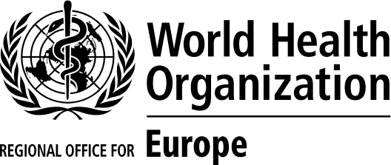
 | 16 March 2020
COVID-19 Ministerial Meeting (53 Member States)
WHO European Region

11:00–13:00  17 March 2020 | ORIGINAL: ENGLISH
Provisional programme
Tuesday, 17 March 2020
11:00–11:05 | Welcome remarks  Dr Hans Henri P. Kluge, Regional Director, WHO Regional Office for Europe
11:05–11:10 | The global COVID-19 situation  Dr Michael Ryan, Executive Director, WHO Health Emergencies Programme, WHO headquarters
11:10–11:15 | COVID-19 in the WHO European Region and the role of the Regional Office  Dr Hans Henri P. Kluge, Regional Director, WHO Regional Office for Europe
11:15–12:50 | Moderated discussion, questions and answers:  Ministries of health of the 53 Member States of the European Region and the Region’s COVID-19 Incident Management Team
12:50–13:00 | Action points, conclusions and closing remarks  Dr Hans Henri P. Kluge, Regional Director, WHO Regional Office for Europe

